**Practices for Lesson 5: Configuring Siebel Tools and Accessories**

Practices for Lesson 5

Overview

In these practices, we will explore various options available in Siebel management console for administration and configuration activities.

**Practices for Lesson 5-1: Siebel Configurations and Siebel Profile Management**

**Overview:**

In this practice, we will explore various options available in Siebel management console for administration and configuration activities.

Assumptions

You should have completed the Practices of Lesson 4.

**Tasks**

1. Open the browser and provide the Siebel management Console URL 🡪 <http://public-ip-address:4430/siebel/smc>
2. Login with username as **sadmin/XXX** (Password will be provided by the Instructor)

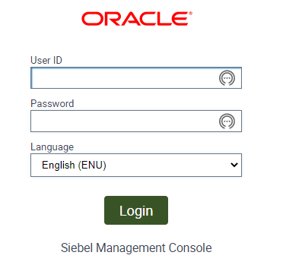

1. Review the Siebel Deployment Profile for your installation.

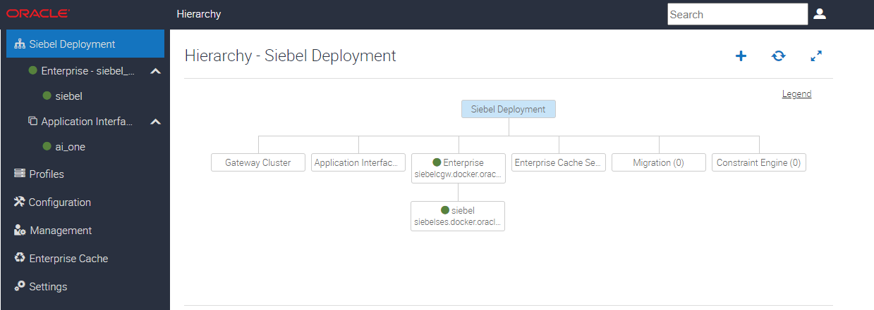

1. You will see an AI, Gateway Cluster, Siebel Server (4430) under Siebel Enterprise Server.
2. Click on **Profiles** link in left navigation Pane.

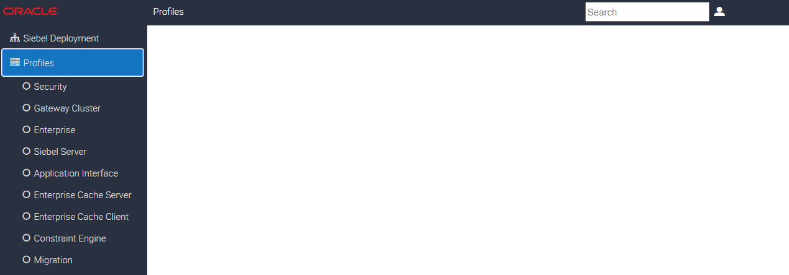

1. Click on **Security** Profile. This provides information about the Security Adapter. Now, click on **Data Sources** Tab under the detailed page (default). You will be able to see the database and connection properties.

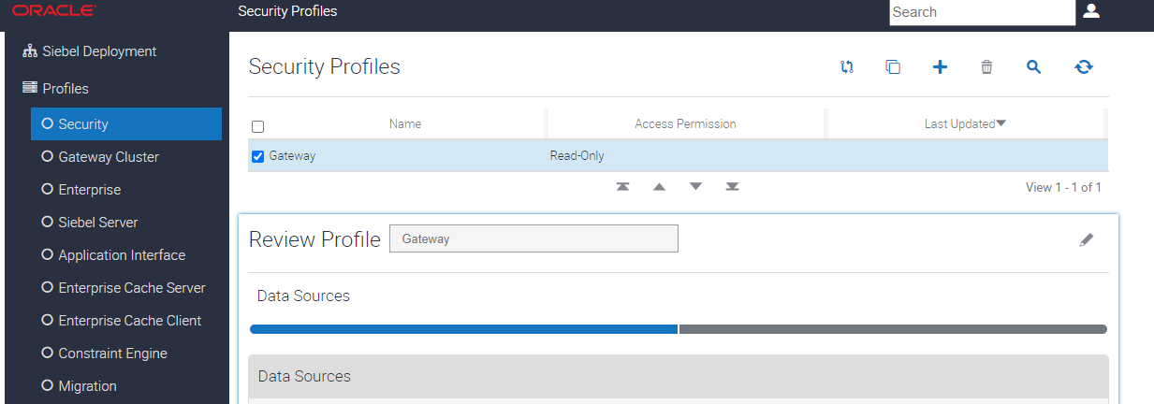

1. Click on **Security Information** Tab on the page. The details of security adapter will be displayed. It details about DBSecAdapter (Database Security Adapter), default authentication page.

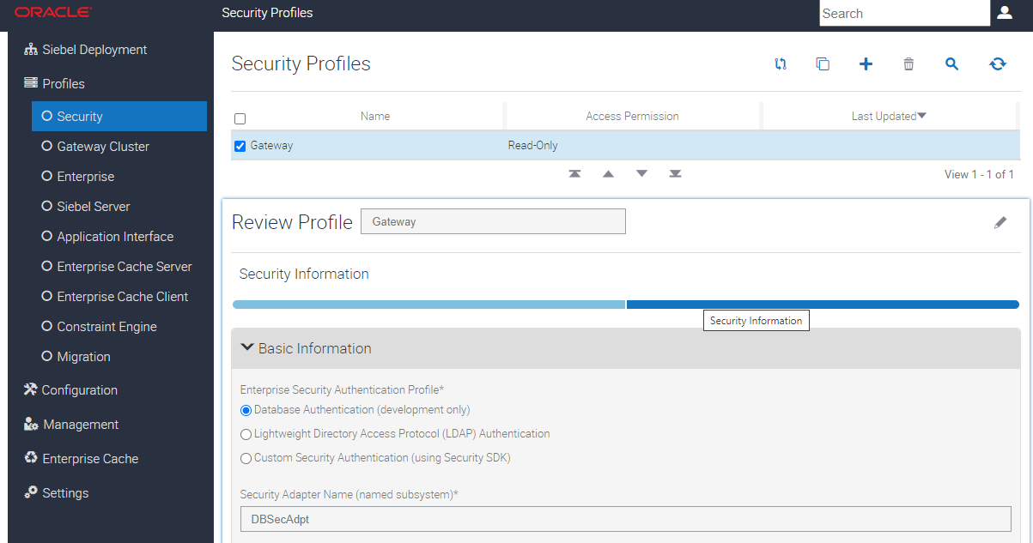

1. Click on **Enterprise** link below. This page provides details of Gateway server, authentication and Database for the Enterprise. Review the panes as shown below, you will see Gateway, Authentication and Security.

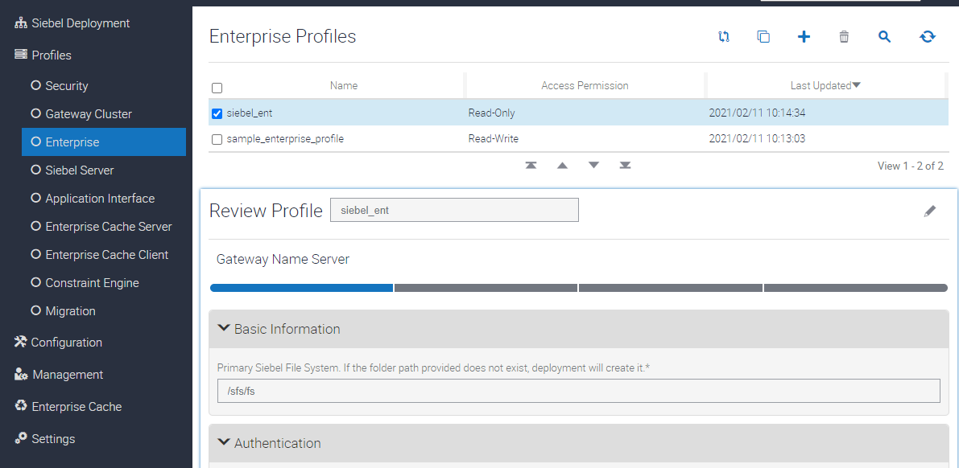

1. Click **Siebel Server** Profile. You will be able to see the different applications installed in the server.

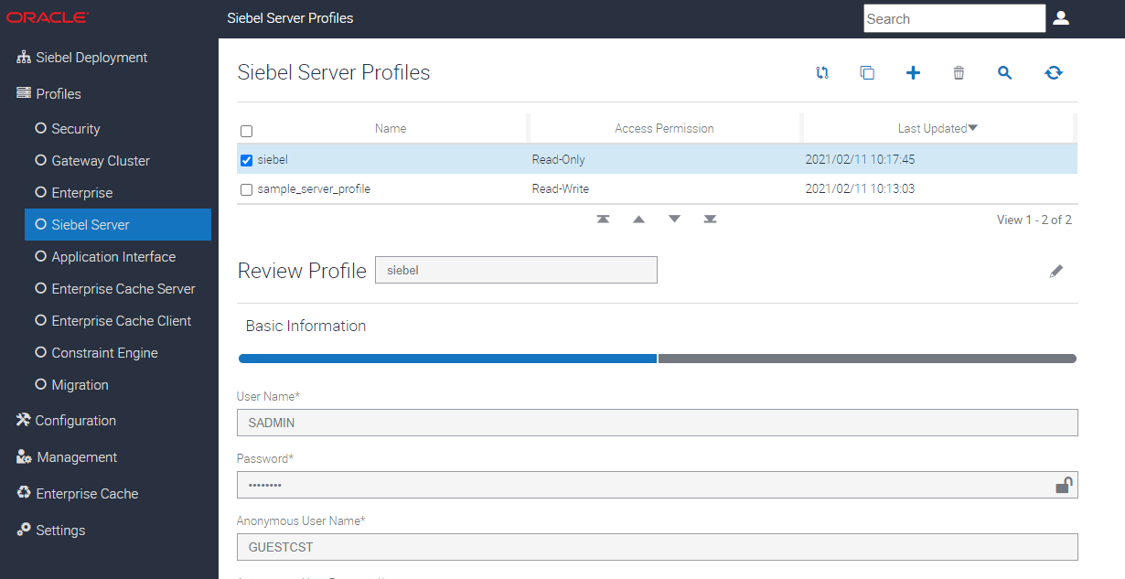

1. Under the Basic Information, the details of the App are shown below.

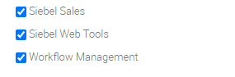

1. Click on **Application Interface**.

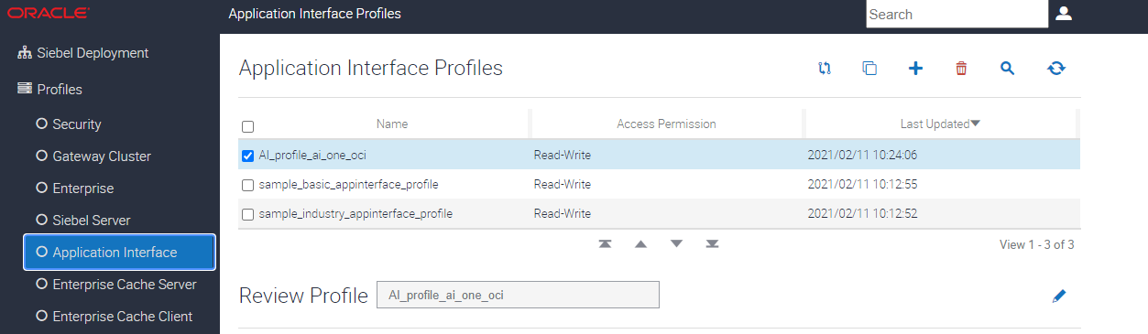

1. Click **Managemen**t in Left Navigation Menu

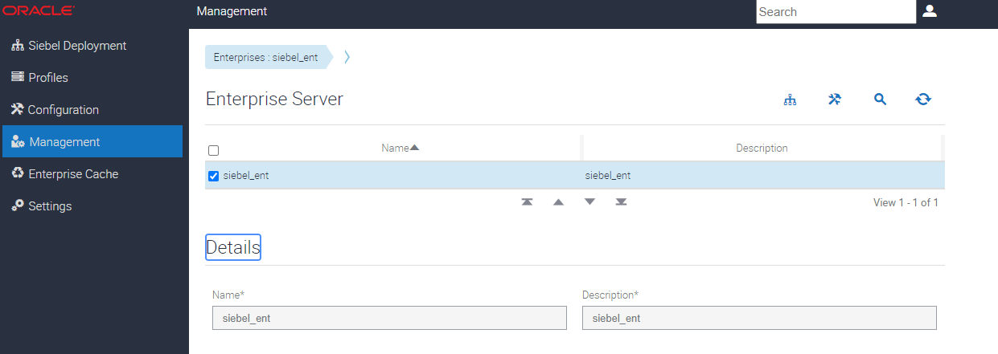

1. Click **on Servers** as shown below.

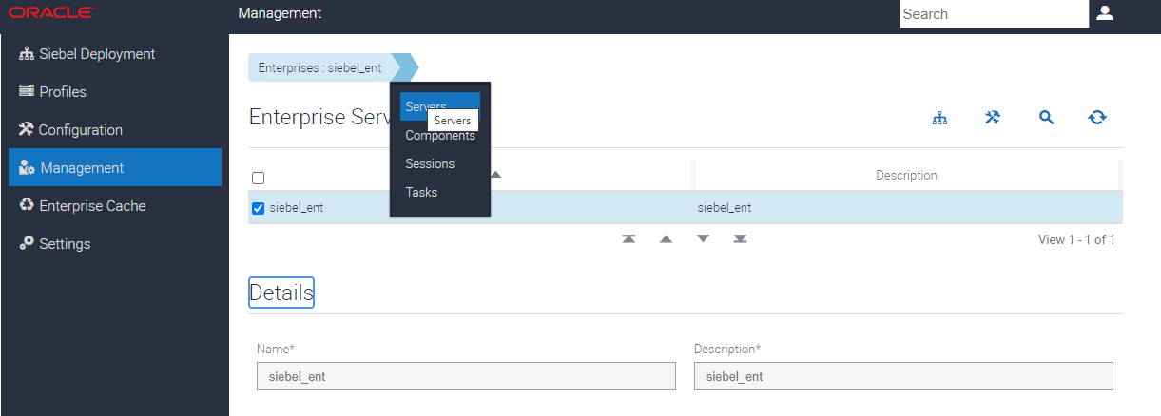

1. Now here, you can start up and shutdown Siebel Server. In a Real case of many Siebel servers, you can start/stop specific Siebel server.

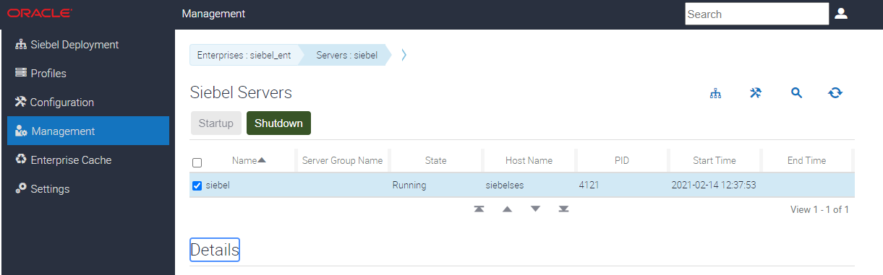

1. Click on the Icon for **Deployment** Properties to view your configuration as shown below.

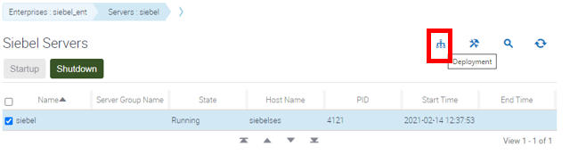

1. Once reviewed, Click on Management Link on left navigation menu to come to menu to perform the next activity.

**Practice for Lesson 5-2: Verifying Siebel Tools Installation and Validations**

**Overview**

In this practice, we will explore various Siebel tools and applications installed for Siebel instance.

Assumptions

You should have completed the Practice of Lesson 5-1.

**Tasks**

1. Open the browser and provide the Siebel Management Console URL - https://<public-ip>:4430/siebel/smc

Username - sadmin

Password will be advised by Instructor.



1. The Siebel Web Tools is an integrated web tool component to edit build Siebel objects and repository management. Provide the WebTools URL in the browser

url : http://<<public-ip>>:4430/siebel/app/webtools/enu

Username - sadmin

Password will be advised by facilitator.

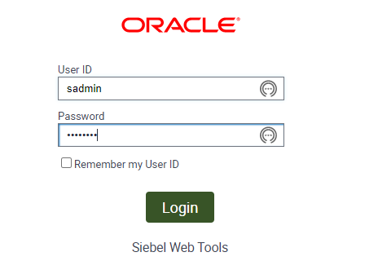

1. Now the Component which is required for the application. Apps URL : http://<siebel-ip-instance>:4430/siebel/app/sales/enu

Sales –Name of the module

Enu – Language of Installation.

